Charles E. Ashbaucher
1873 – September 2, 1914

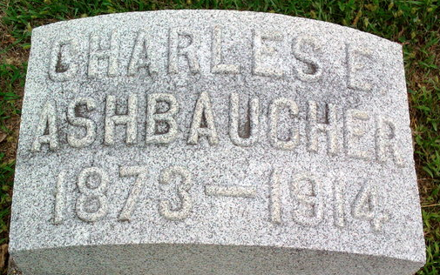
Photo by Thomas Liby
CHARLES ASHBAUCHER ATTACKED BY APOPLEXY
OXFORD, Ohio, Sept. 1 – Charles Ashbaucher, aged 39, a traveling salesman of Indianapolis, 2036 Cornell Avenue, was stricken with apoplexy yesterday evening when soliciting business from the purchasing agent of Miami University. Mr. Ashbaucher represents the Associated Manufacturers' Company of Milwaukee and sells janitor's supplies. He is unconscious at the home of Mr. and Mrs. Albine Slonker and his condition is critical. His family has been summoned from Indianapolis, also his brother, Frank Ashbaucher, of Bluffton, Ind.
Mr. Ashbaucher is a member of the Masonic and Knights of Pythias fraternities in Indianapolis.
Journal Gazette, Allen County, Indiana
September 2, 1914
**
LINN GROVE NEWS
Mrs. Jacob Meshberger and daughter, Daisy, Mr. and Mrs. Levy Atz, Mr. and Mrs. D. F. Hoffmann, Ed Bauman attended the funeral of Charles Ashbaucher at Bluffton on Sunday.
Journal Gazette; Allen County, Indiana
Wednesday, September 9, 1914
**
Charles E Ashbaucher from Ashbaucher Family Tree
Spouse Minnie P. Hathaway
Father John Ashbaucher
Mother Malissa Bollinger
Birth Dec 1875 Indiana, USA
Death 13 Sep 1914
Residence 1909 Indianapolis, Marion, Indiana, USA

