Benjamin Ashbaucher
October 19, 1859 – March 13, 1912

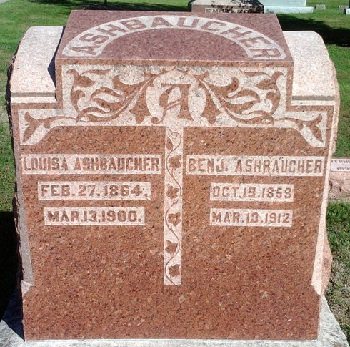
Photo by Thomas Liby
Benjamin Ashbaucher, fifty-three years of age, of Bluffton, Ind., died after suffering for two weeks with paralysis. He was one of the city's prominent businessmen and one of the leaders of the First Reformed Church of that city.

The Van Wert Daily Bulletin, Mar 15, 1912
Van Wert, Ohio
**

Indiana, U.S., Death Certificates, 1899-2017
Name Benjamin Ashbaucher
Gender Male
Race White
Age 52
Marital Status Married
Birth Date 19 Oct 1859
Birth Place Wayne Co Ohio
Death Date 13 Mar 1912
Death Place Harrison, Wells, Indiana, USA
Death Registration Date 1912
Father: John Ashbacher
Mother: Anne Schone
Spouse: Ida Mast
Informant: Mrs. B. Ashbaugher [sic]; Bluffton, Indiana
Burial: March 15, 1912; Fairview Cemetery

