Benjamin Franklin Ashbaucher
May 13, 1871 – April 15, 1930

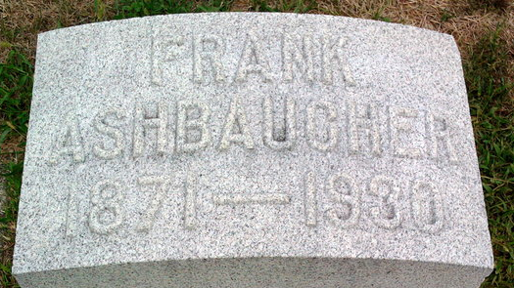
Photo by Thomas Liby

B. Frank Ashbaucher
in the Indiana, U.S., Death Certificates, 1899-2017
Name B. Frank Ashbaucher
Gender Male
Race White
Age 58
Marital Status Married
Birth Date 13 May 1871
Birth Place Adams Co Indiana
Death Date 15 Apr 1930
Death Place Bluffton, Wells, Indiana, USA
Death Registration Date 1930
Father: John Ashbaucher
Mother: Malisa Bolinger
Spouse: Lillie Faulk
Informant: Mrs. Frank Ashbaucher; Bluffton, Indiana
Burial: April 17, 1930; Fairview Cemetery

