Wilson Arnold
April 28, 1881 – June 2, 1881

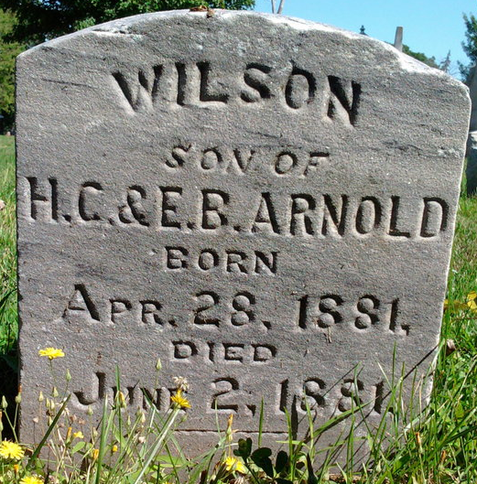
Photo by Thomas Liby

Wilson Arnold from Blanton Family Tree
Father Henry Clay Arnold
Mother Eliza Mann
Birth 28 Apr 1881
Death 2 Jun 1881

