Samuel Junior Arnold
February 18, 1923 – July 31, 1991

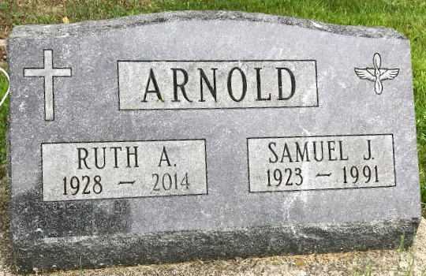
Photo by SMMR
Samuel Junior Arnold from Jody Padgett Family Tree
Spouse Ruth Wilson
Father Samuel Ervin Arnold
Mother Bernice Herbst
Children Sandra Jean
Birth 18 Feb 1923 Bluffton, Wells, Indiana, USA
Death 31 Jul 1991 Bel Air South, Harford, Maryland, USA
Residence 1942 Bluffton, Wells, Indiana, USA
**
U.S., Department of Veterans Affairs BIRLS Death File, 1850-2010
Name Samuel J Arnold
Gender Male
Birth Date 18 Feb 1923
Death Date 31 Jul 1991
SSN xxx
Enlistment Branch ARMY
Enlistment Date 4 Feb 1943
Discharge Date 12 Dec 1945
Page number 1

