Samuel E. Arnold
November 1, 1882 – September 21, 1949

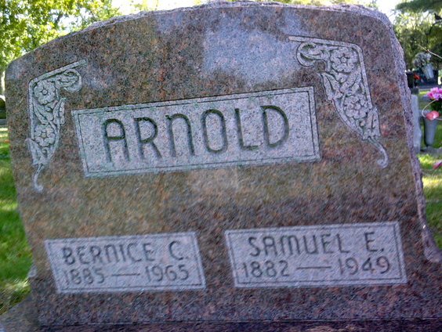
Photo by Thomas Liby

Samuel E Arnold
in the Indiana, U.S., Death Certificates, 1899-2017
Name Samuel E Arnold
Gender Male
Race White
Age 66
Marital Status Married
Birth Date 1 Nov 1882
Birth Place Indiana
Death Date 21 Sep 1949
Death Place Bluffton, Wells, Indiana, USA
Death Registration Date 1949
Father: Adam Arnold
Mother: Julia Lanning
Informant: Mrs. S. Arnold; Bluffton, Indiana
Burial: September 24, 1949; Fairview Cemetery; Bluffton, Indiana

