Samantha Elizabeth “Lizzie” (Johnston) Arnold
December 27, 1850 – September 12, 1883

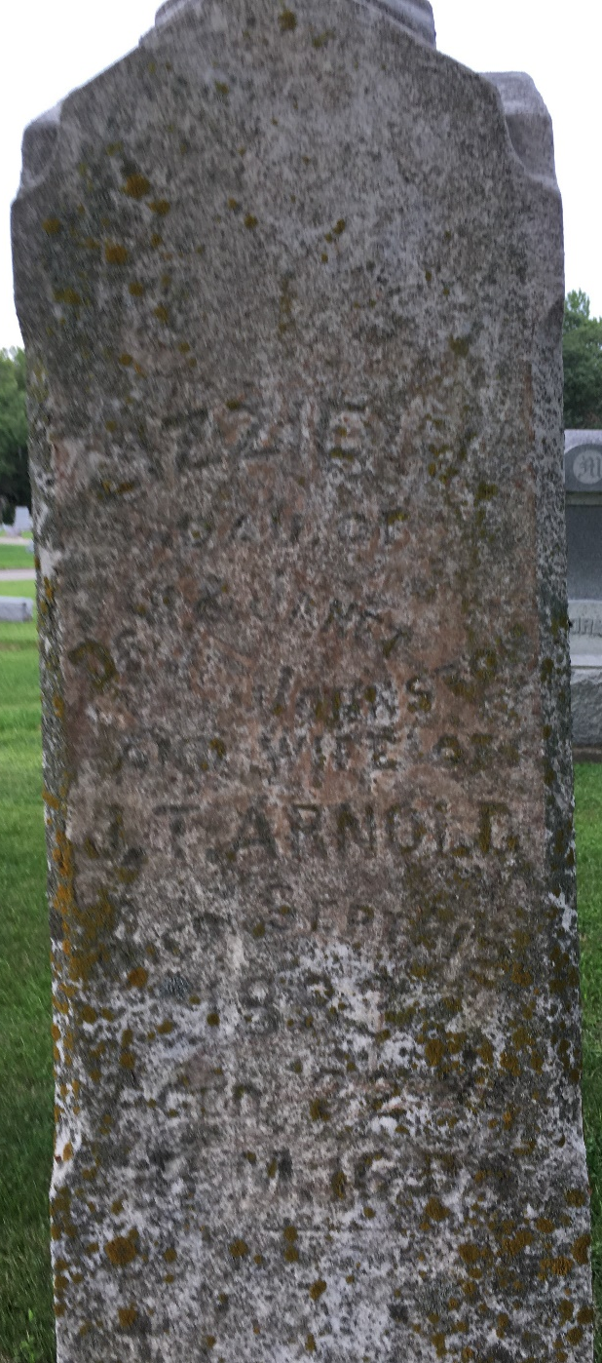
Photo by Barbara Baker Anderson

No further information found at this time

