Ruth Ann (Wilson) Arnold
February 17, 1928 – January 18, 2014

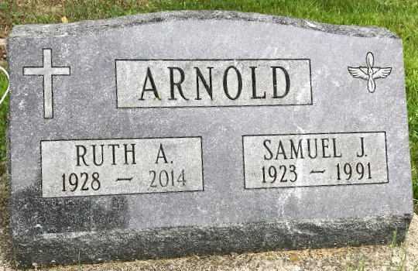
Photo by SMMR
Ruth Ann Arnold, 85, formerly of Wells County, passed away Saturday, Jan. 18, 2014, at Forest Hill Health & Rehab Center in Forest Hill, Md. She was born Feb. 17, 1928, in Wells County to Charles L. Wilson and Margret I. McFarren Wilson. She married Samuel J. Arnold Jr. Aug. 27, 1943, in Bluffton; he preceded her in death July 31, 1991.
Ruth Ann was a homemaker and a minister's wife. She was a loving mother and grandmother. She was a member of Mountain Christian Church in Maryland.
Survivors include two daughters, Cathy J. Flair of Ocean City, Md., and Rebecca Atkins of Mechanicsville, Md.; two sons, David L. (Brenda) Arnold of Lansing, Mich., and Timothy W. Arnold of Forest Hill, Md.; two sisters, Doris (Gerald) Lucas of Warsaw and Mary Jane Falk of Bluffton; a brother, Roger (Markeeta) Wilson of Bluffton; 15 grandchildren; and several great- and great-great-grandchildren.
Ruth Ann was preceded in death by a daughter, Sandy Hippard, and three sisters, Helen Meyer, Mona Jean Boyle and Janet K. Fahl.
A memorial service will be held at 2:30 p.m. Sunday, April 27, at Bluffton First Church of Christ with Larry Sprinkle officiating. Burial will be at Fairview Cemetery.
Memorials may be made to Feed the Children.

Goodwin Funeral Homes, Wells County, Indiana
January 19, 2014

