Orville A. Arnold
July 16, 1903 – February 24, 1940

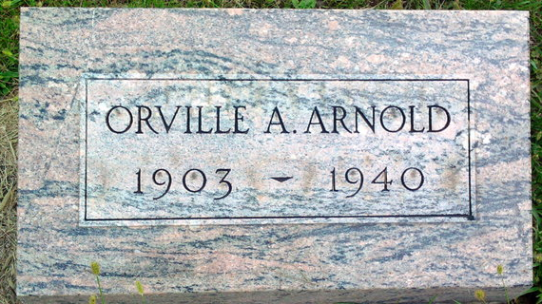
Photo by Thomas Liby
Mother, Son Die Within 36 Hours

Bluffton, Feb. 26 – Mrs. Carrie Myrtle Arnold, 63, of near Keystone died early today at the Wells County Hospital here, 36 hours after the death of her son, Orville A. Arnold, 36, and arrangements were completed for double funeral services to be held at 2 pm Wednesday at the Petroleum U. B. Church, with burial in the Fairview Cemetery, Bluffton. The bodies were taken to the Thoma Funeral Home in this city and will be there until the time for the rites at the church.
Another son, Irvin, is a patient at the hospital, a sufferer from pneumonia, the same malady that caused the death of Mrs. Arnold and the older son, but he was believed on the road to recovery.
Surviving are the husband and father, Allison Arnold, and six other children, Harold, Clifford and Clancy, all of Nottingham Township, Franklin Arnold of Greenfield, Paul Arnold of California and Mrs. Herman Borchers of Chicago; the brothers and sisters, Quincy and Manville Wooten of Morristown, John Wooten of Spencer, Mrs. Scott Lowder, Reason Wooten and Esther Wooten, all of Hancock County; Mrs. Ethel Beck of Knightstown, and Mrs. Ruby Hanley of Marion County, and the stepmother, Mrs. N. J. Wooten of Greenfield.

Journal-Gazette, Allen County, Indiana
February 27, 1940
**

Indiana, U.S., Death Certificates, 1899-2017
Name Orville Arnold
Gender Male
Race White
Age 36
Marital Status Single
Birth Date 16 Jul 1903
Birth Place Hancock Co Indiana
Death Date 24 Feb 1940
Death Place Bluffton, Wells, Indiana, USA
Death Registration Date 1940
Father: Allison O Arnold
Mother: Carrie M Wootern
Informant: Allison Arnold; Keystone, Indiana
Burial: February 26, 1940; Burial place not stated

