Mildred E. Arnold
November 6, 1916 – August 29, 1967

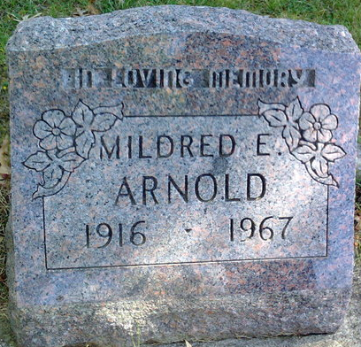
Photo by Thomas Liby

Mildred E Arnold
in the Indiana, U.S., Death Certificates, 1899-2017
Name Mildred E Arnold
Gender Female
Race White
Age 50
Marital Status Never Married (Single)
Birth Date 6 Nov 1916
Birth Place Wells Co Indiana
Death Date 29 Aug 1967
Death Place Indianapolis, Marion, Indiana, USA
Death Registration Date 1967
Father: Samuel E Arnold
Mother: Bernice Herbst
Informant: Mrs. Robert Markley; sister; Bluffton, Indiana
Burial: September 2, 1967; Fairview Cemetery; Bluffton, Indiana

