Mary B. (Burgess) Arnold
June 21, 1906 – November 17, 2002

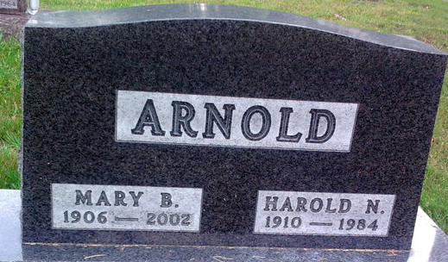
Photo by Thomas Liby
A retired bookkeeper and former school teacher, Mary B. Arnold, 96, a resident of Christian Care Retirement Center, died unexpectedly of natural causes at 2:45 p.m. Sunday, November 17, 2002 at Bluffton Regional Medical Center.
Mrs. Arnold retired in 1975 after 17 years as bookkeeper for Miller Roofing Co. Earlier, after completing two years in teacher training at Ball State University, she taught for seven years at Chester Center School and was the holder of a lifetime teacher's license. She was a graduate of Petroleum High School. She was a member of the First United Methodist Church in Bluffton.
She was born in Wells County June 21, 1906, the only child of Richard and Hattie Roberts Burgess. Her marriage at Coldwater Mich., in 1936 was to Harold Arnold, who died June 21, 1984.
Surviving are two sons, Dean K. of New Albany and Richard A. of Fort Wayne; six grandchildren; and two great-grandchildren.
Services will be held at 11 a.m. Wednesday at Thoma/Rich, Hewitt & Chaney Funeral Home with Pastor William Shannon officiating. Burial will be in Fairview Cemetery. Calling hours at the funeral chapel will be Tuesday from 2 to 8 pm. and Wednesday for one hour prior to services.
Memorials to the First United Methodist Church.

Bluffton News-Banner, Wells County, Indiana
November 18, 2002

