Margaret Arnold
December 26, 1888 – January 17, 1915

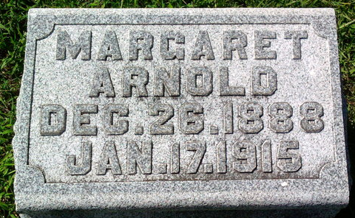
Photo by Thomas Liby

Miss Margaret Arnold, daughter of Mr. and Mrs. Charles Arnold, died Sunday morning at her home in Bluffton. She was widely known in this city. The funeral will be held at 2 o'clock Tuesday afternoon.

Fort Wayne News, Allen County, Indiana
January 18, 1915
**
Indiana, U.S., Death Certificates, 1899-2017
Name Margaret Arnold
Gender Female
Race White
Age 26
Marital Status Single
Birth Date 26 Dec 1888
Birth Place Bluffton Indiana
Death Date 17 Jan 1915
Death Place Bluffton, Wells, Indiana, USA
Death Registration Date 1910 - 1919
Father: Charles A Arnold
Mother: Cathine C. Wall
Informant: Charles A. Arnold; Bluffton, Indiana
Burial: January 19, 1915; Fairview Cemetery

