Lelia Arnold
April 12, 1868 – April 26, 1953

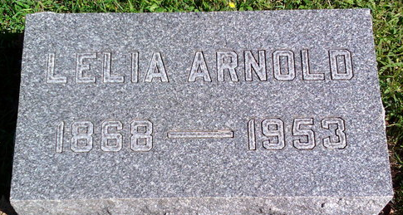
Photo by Thomas Liby
Lelia Arnold
in the Tennessee, U.S., Death Records, 1908-1965
Name Lelia Arnold
Gender Female
Race White
Age 85
Birth Date 12 Apr 1868
Birth Place USA
Death Date 26 Apr 1953
Death Place Nashville, Davidson, Tennessee, USA
Father: Henry C Arnold
Mother: Eliza Bulger
Informant: Mrs. A. M. Weesner; same address
Removal: April 27, 1953; Bluffton, Indiana
Certificate Number 53-08183

