Katherine E. Arnold
January 6, 1858 – April 17, 1901

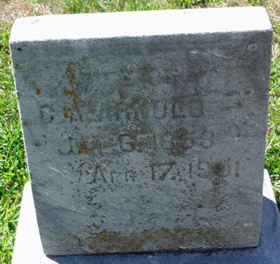
Photo by Thomas Liby
Mrs. C. A. Arnold died Wednesday, April 17th, at her home in St. Marys, Ohio, after an illness of ten days. She was first taken with a severe attack of pleurisy, which developed into pneumonia, and lingered a week when death came to her relief. The deceased was born in Mahoning county, Ohio, January 6th, 1858, and was forty-three years, three months and eleven days old at the date of her death.
Miss Katherine Wall was the daughter of Rev. Fredrick Wall, at one time pastor of the Reformed church of Bluffton. She was united in marriage to Charles A. Arnold December 20th, 1878. Seven children were born to this union, Albert Garfield, Anna Louise, Sherman B., Margaret, Sarah and Donald Fredrick, who are still living. She was a faithful member of the M. E. church and lived a consistent Christian life which was devoted to the happiness of her husband and children. She also leaves surviving her four brothers, one sister and her mother.
Mr. and Mrs. Arnold removed from Bluffton in 1896 to Camden, and two years later took up their residence in St. Marys, Ohio. The deceased leaves a host of friends who extend their sympathy to the family in their affliction.

Bluffton Chronicle, Wells County, Indiana
Wednesday, April 24, 1901, p. 9, c. 4

