Infant Arnold
December 13, 1909 – October 12, 1911

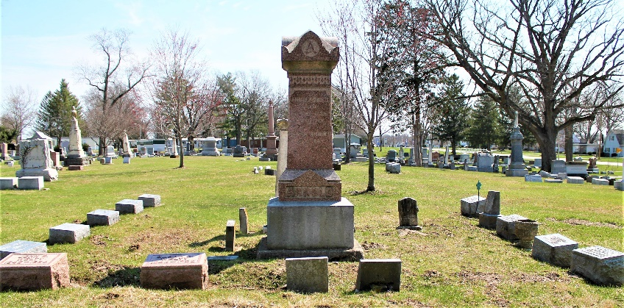

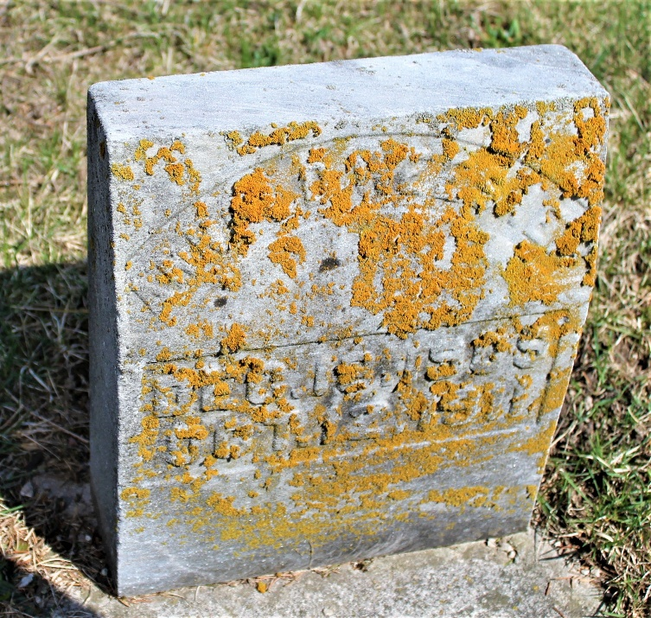
Photos by C Johnson

No further information found at this time

