Henry Clay Arnold
May 2, 1843 – April 3, 1933

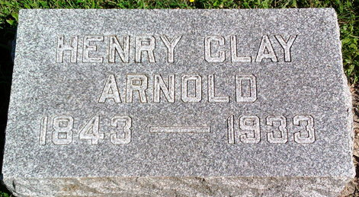
Photo by Thomas Liby
Henry C. Arnold
in the Indiana, U.S., Death Certificates, 1899-2017
Name Henry C. Arnold
Gender Male
Race White
Age 89
Marital Status Married
Birth Date 2 May 1843
Birth Place Whitley Co. Indiana
Death Date 3 Apr 1933
Death Place Bluffton, Wells, Indiana, USA
Death Registration Date 1933
Father: George Arnold
Mother: Ann Welty
Spouse: Eliza Bulger
Informant: Geo. L. Arnold; Bluffton, Indiana
Burial: April 5, 1933; Fairview Cemetery

