Henry C. Arnold
June 28, 1875 – September 30, 1875

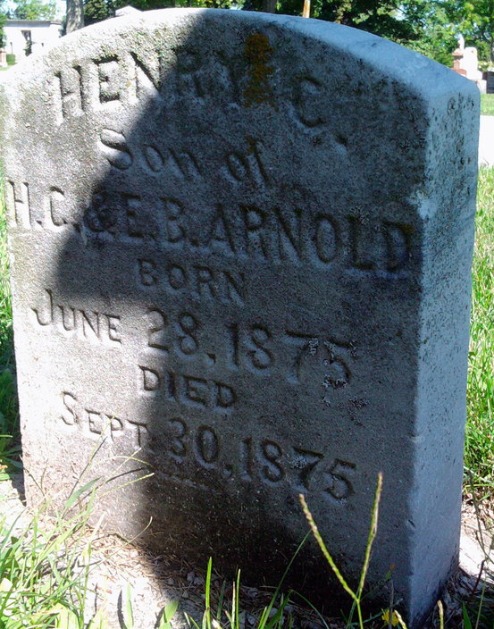
Photo by Thomas Liby
No further information found at this time

