Harold Newton Arnold
January 21, 1910 – June 21, 1984

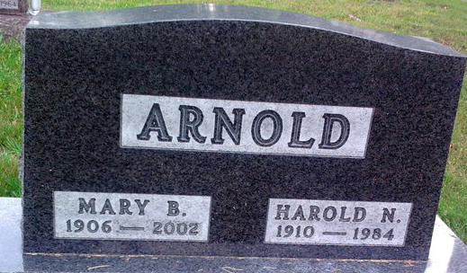
Photo by Thomas Liby
Harold N. Arnold
in the Indiana, Death Certificates, 1899-2011
Name: Harold N. Arnold
Gender: Male
Race: White
Age: 74
Marital status: Married
Birth Date: 21 Jan 1910
Birth Place: N. Dakota
Death Date: 21 Jun 1984
Death Place: Bluffton, Wells, Indiana, USA
Father: Allison Arnold
Mother: Carrie Wooton
Spouse: Mary B. Burgess
Informant: Mary B. Arnold; wife; Bluffton, Indiana
Burial: June 23, 1984; Fairview Cemetery; Bluffton, Indiana

