George L. Arnold
October 13, 1876 – October 11, 1972

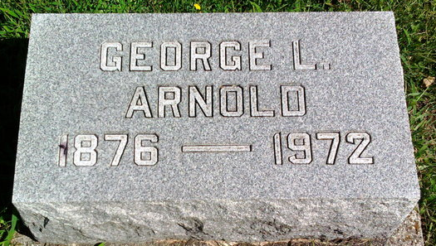
Photo by Thomas Liby
George L. Arnold, 95, of 326 South Main Street, a retired grain dealer, died Wednesday at Clinic Hospital. A native of Bluffton and a life resident of Wells County, he was born October 13, 1876, a son of Henry C. and Eliza Bulger Arnold. He was married October 16, 1907 to Alice Fulton at Bluffton. She died March 22, 1957. He was the last of a family of five children.
Surviving are one niece and four nephews. He was a member of the First United Methodist Church.
Funeral services will be Saturday at the Thoma Funeral Home, Rev. John Hall officiating. Burial will be in Fairview Cemetery.

Wells County, Indiana Obituaries
October 11, 1972

