George Arnold
September 27, 1818 – August 11, 1904

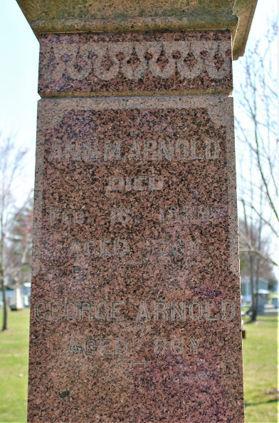
Photo by Thomas Liby
George Arnold
in the Indiana, U.S., Death Certificates, 1899-2017
Name George Arnold
Gender Male
Race White
Age 85 years, 10 months, 24 days
Marital Status Married
Birth Date 27 Sep 1818
Birth Place Ohio
Death Date 11 Aug 1904
Death Place Bluffton, Wells, Indiana, USA
Death Registration Date 1904
Father: Wm Arnold
Mother: Townsend
Spouse: Adaline
Informant: H. C. Arnold; Bluffton, Indiana
Burial: August 14, 1904; Fairview Cemetery

