Eliza (Bulger) Arnold
April 10, 1842 – July 2, 1935

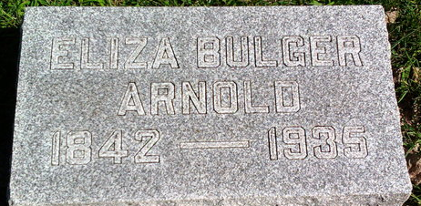
Photo by Thomas Liby
Eliza Bulzer Arnold
in the Indiana, U.S., Death Certificates, 1899-2017
Name Eliza Bulger Arnold
Gender Female
Race White
Age 93
Marital Status Widowed
Birth Date 10 Apr 1842
Birth Place Wells Co Indiana
Death Date 2 Jul 1935
Death Place Bluffton, Wells, Indiana, USA
Death Registration Date 1935
Father: Wilson Bulger
Mother: Affia Mann
Spouse: Henry E Arnold
Informant: Geo. L. Arnold; Bluffton, Indiana
Burial: July 5, 1935; Fairview Cemetery; Bluffton, Indiana

