Edith (Miller) Arnold
January 28, 1891 – November 19, 1972

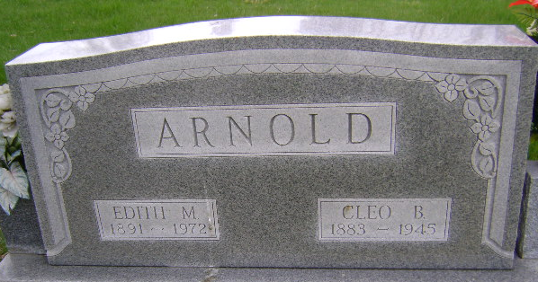
Photo by Bruce Sonner
Mrs. Edith Miller Arnold, 81, 403 West South Street, died Sunday at the Cooper Rest Home. She was a former City-Clerk-Treasurer of Bluffton. A native of Bluffton, she was born January 28, 1891, a daughter of Charles and Lizzie Burgner Miller. Her marriage to Mr. Arnold took place in Bluffton, January 7, 1914.
She was a life resident of Wells County and a member of the First Methodist Church.
Surviving are three daughters, Mrs. Hardy (Marjorie) Swenson of Birmingham, Alabama, Mrs. Sylvan (Alice) Bertsch of Bluffton and Mrs. Cloyd (Charleen) Farling, Tampa, Florida; one brother, Dwight C. Miller of Kansas City, Kansas; 10 grandchildren and four great grandchildren.
Services will be Tuesday at the Thoma Funeral Home, Rev. Robert Jackson officiating; burial in Fairview Cemetery.

Wells County, Indiana Obituaries
November 19, 1972

