Donald Frederick Arnold
October 28, 1900 – September 14, 1912

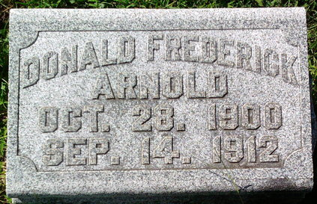
Photo by Thomas Liby
Donald Frederick Arnold
in the Indiana, U.S., Death Certificates, 1899-2017
Name Donald Frederick Arnold
Gender Male
Race White
Age 11
Marital Status Single
Birth Date 28 Oct 1900
Birth Place St Marys O.
Death Date 14 Sep 1912
Death Place Harrison, Wells, Indiana, USA
Death Registration Date 1912
Father: Chas A Arnold
Mother: Cathern Wall
Informant: Chas. A. Arnold; Bluffton, Indiana
Burial: September 17, 1912; Fairview Cemetery

