Cleo B. Arnold
January 24, 1883 – December 31, 1945

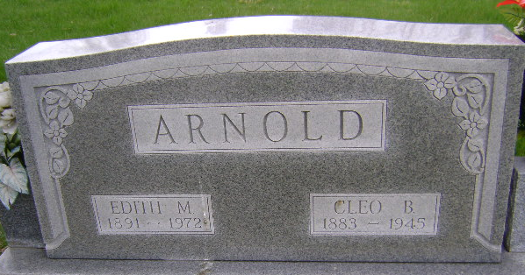
Photo by Bruce Sonner
Oles B Arnold
in the Indiana, U.S., Death Certificates, 1899-2017
Name Cleo B Arnold
Gender Male
Race White
Age 62
Marital Status Married
Birth Date 24 Jan 1884(sic)
Birth Place Angola Indiana
Death Date 31 Dec 1945
Death Place Bluffton, Wells, Indiana, USA
Death Registration Date 1945
Father: Lafayette Arnold
Mother: June Jones
Spouse: Edith; age 53
Informant: Mrs. Cleo Arnold
Burial: January 3, 1946; Fairview Cemetery; Bluffton, Indiana

