Charles A. Arnold
February 5, 1852 – September 22, 1932

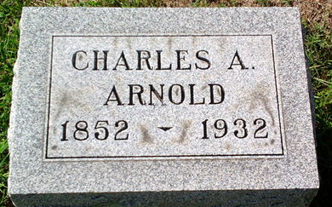
Photo by Thomas Liby
Charles A Arnold
in the Indiana, U.S., Death Certificates, 1899-2017
Name Charles A Arnold
Gender Male
Race White
Age 80
Marital Status Married
Birth Date 5 Feb 1852
Birth Place Columbia City Indiana
Death Date 22 Sep 1932
Death Place Bluffton, Wells, Indiana, USA
Death Registration Date 1932
Father: George Arnold
Mother: Ann Marie Welty
Spouse: Katherine Wisner
Informant: Mrs. Charles Arnold; Bluffton, Indiana
Burial: September 25, 1932; Fairview Cemetery

