Charles Arnold
October 26, 1865 – January 14, 1933

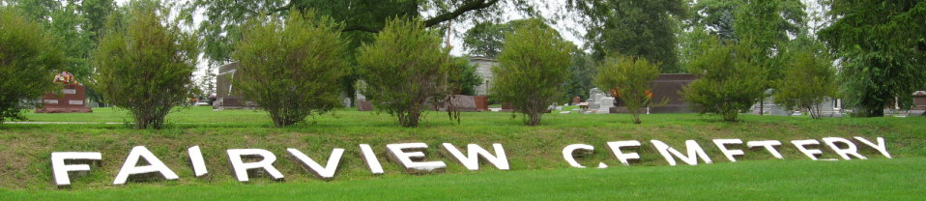
Photo by Tombstoner & Family
Charles Arnold
in the Indiana, U.S., Death Certificates, 1899-2017
Name Charles Arnold
Gender Male
Race White
Age 55 years, 10 months, 26 days
Marital Status Divorced
Birth Date
Birth Place Indiana
Death Date 14 Jan 1933
Death Place Wayne, Indiana, USA
Death Registration Date 1933
Father: William Arnold
Mother: Elizabeth Chrisman
Informant: Hospital records; Richmond State Hospital
Burial: January 17, 1933; Bluffton, Indiana

