Catherine E. (Wesener) Arnold
December 30, 1860 – February 20, 1940

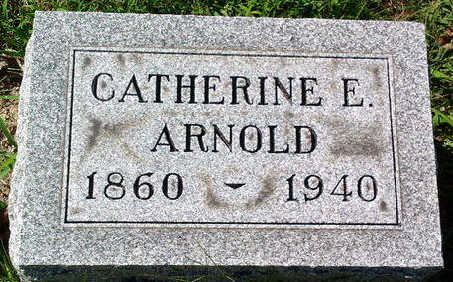
Photo by Thomas Liby

Bluffton, Feb. 21 – Mrs. Catherine E. Arnold, 79, widow of Charles A. Arnold, died last night at the Wells County Hospital here of complications. She was born in Huntington and had resided in Bluffton 35 years.
Stepchildren surviving are Albert Arnold of Elwood, Mrs. Anna Sherbondy of Cleveland, Sherman Arnold of Berea, O., and Mrs. Herman Wiecking of Bluffton.
She was a member of the First Methodist Church.
Funeral services will be held at 2:30 pm Thursday at the Thoma Funeral Home in charge of Rev. E. R. Garrison and burial will be in Fairview Cemetery.

Journal-Gazette, Allen County, Indiana
February 22, 1940
**

Indiana, U.S., Death Certificates, 1899-2017
Name Catherine E Arnold
[Catherine E Wesener]
Gender Female
Race White
Age 79
Marital Status Widowed
Birth Date 30 Dec 1860
Birth Place Huntington
Death Date 20 Feb 1940
Death Place Bluffton, Wells, Indiana, USA
Death Registration Date 1940
Father: Al Wesener
Mother: Susan Trusler
Spouse: Charles A Arnold
Informant: Mrs. Herman Wiecking; Bluffton, Indiana
Burial: February 22, 1940; Fairview Cemetery; Bluffton, Indiana

