Carrie Myrtle (Wooten) Arnold
August 14, 1877 – February 26, 1940

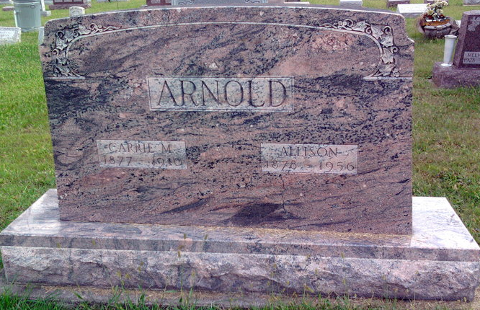
Photo by Thomas Liby

Mother, Son Die Within 36 Hours

Bluffton, Feb. 26 – Mrs. Carrie Myrtle Arnold, 63, of near Keystone died
early today at the Wells County Hospital here, 36 hours after the death of
her son, Orville A. Arnold, 36, and arrangements were completed for
double funeral services to be held at 2 pm Wednesday at the Petroleum
U. B. Church, with burial in the Fairview Cemetery, Bluffton. The bodies
were taken to the Thoma Funeral Home in this city and will be there until
the time for the rites at the church.
Another son, Irvin, is a patient at the hospital, a sufferer from
pneumonia, the same malady that caused the death of Mrs. Arnold and
the older son, but he was believed on the road to recovery.
Surviving are the husband and father, Allison Arnold, and six other
children, Harold, Clifford and Clancy, all of Nottingham Township,
Franklin Arnold of Greenfield, Paul Arnold of California and Mrs.
Herman Borchers of Chicago; the brothers and sisters, Quincy and
Manville Wooten of Morristown, John Wooten of Spencer, Mrs. Scott
Lowder, Reason Wooten and Esther Wooten, all of Hancock County; Mrs.
Ethel Beck of Knightstown, and Mrs. Ruby Hanley of Marion County,
and the stepmother, Mrs. N. J. Wooten of Greenfield.

Journal-Gazette, Allen County, Indiana
February 27, 1940
**

Indiana, U.S., Death Certificates, 1899-2017
Name Carrie Myrtle Arnold
[Carrie Myrtle Wooten]
Gender Female
Race White
Age 62
Marital Status Married
Birth Date 14 Aug 1877
Birth Place Indiana
Death Date 26 Feb 1940
Death Place Bluffton, Wells, Indiana, USA
Death Registration Date 1940
Father: N J Wooten
Mother: Josephene Allender
Spouse: Allison Arnold; age 61
Informant: Allison Arnold; Keystone, Indiana
Burial: February 28, 1940; Fairview Cemetery; Bluffton, Indiana

