Bernice C. (Herbst) Arnold
July 27, 1885 – February 12, 1965

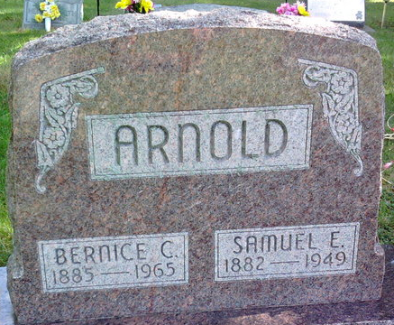
Photo by Thomas Liby
Bernice Arnold
in the Indiana, U.S., Death Certificates, 1899-2017
Name Bernice Arnold
[Bernice Herbst]
Gender Female
Race White
Age 79
Marital Status Widowed
Birth Date 27 Jul 1885
Birth Place Wells County
Death Date 12 Feb 1965
Death Place Bluffton, Wells, Indiana, USA
Death Registration Date 1965
Father: Joseph Herbst
Mother: Drumm
Informant: Mrs. Ruth Markley; daughter; Bluffton, Indiana
Burial: February 14, 1965; Fairview Cemetery; Bluffton, Indiana

