Anna Marie (Welty) Arnold
February 8, 1813 – February 16, 1889

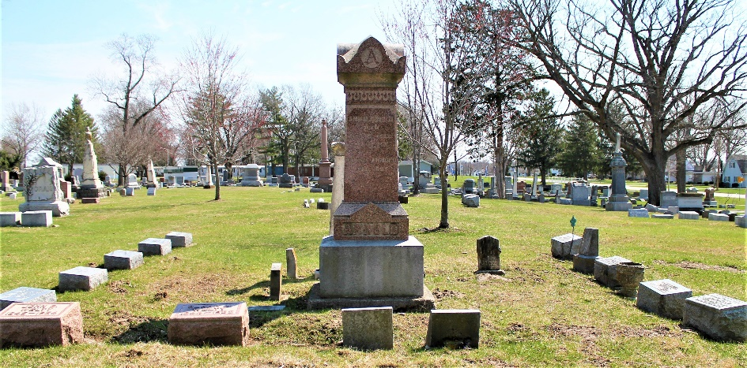

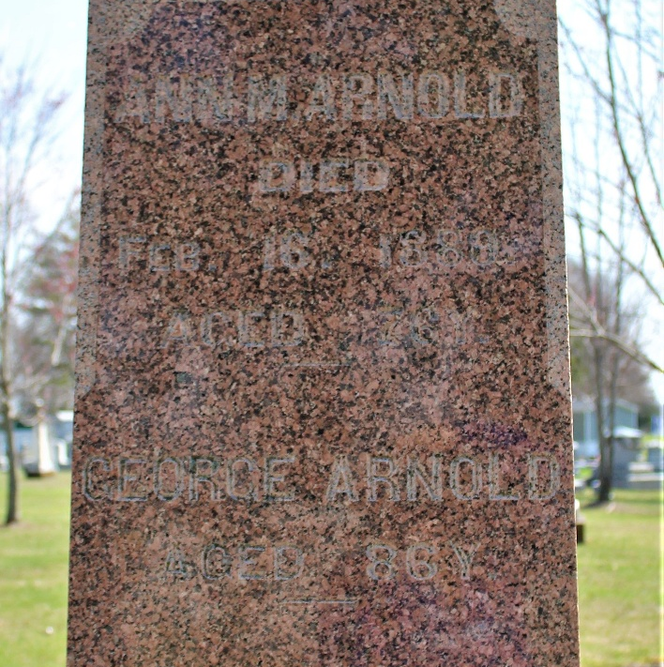
Photos by C Johnson
Anna Maria Welty from tree RUSSELL
Birth 8 Feb 1813 Cumberland, Adams, Pennsylvania, USA
Marriage 10 Nov 1840 Darke, Ohio, USA
Residence 1880 Bluffton, Wells, Indiana, USA
Death 16 Feb 1889 Bluffton, Wells, Indiana, USA
Father John Johannes Welty (1760-1837)
Mother Catherine Weaver (1766-1833)
Spouse George Arnold (1818-1904)

