Allison Arnold
June 16, 1878 – March 15, 1956

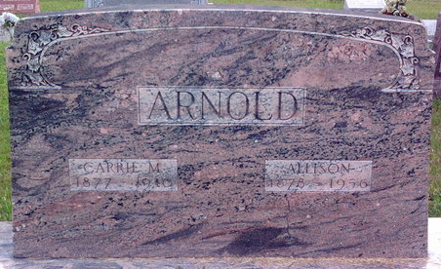
Photo by Thomas Liby
Allison Arnold
in the Indiana, U.S., Death Certificates, 1899-2017
Name Allison Arnold
Gender Female
Race White
Marital Status Widowed
Birth: June 16??, 1878
Death Date 15 Mar 1956
Death Place Indiana, USA
Death Registration Date 1956
Father: Unknown
Mother: Emily Arnold
Informant: Franklin Arnold; son
Burial: March 17, 1956; Can't read location
**
Allison Arnold from Family Tree
Spouse Carrie Myrtle Wooten
Father Kimble E Barnes
Mother Emily Frances Arnold
Children Gerald Franklin
Birth 16 Jun 1878 Shelby, Lake, Indiana, USA
Death 15 Mar 1956 Greenfield, Hancock, Indiana, USA
Residence 1915 Lark, Grant, North Dakota, USA

