Alice (Fulton) Arnold
October 3, 1884 – March 22, 1957

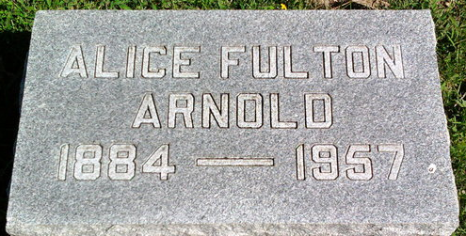
Photo by Thomas Liby
Alice Fulton Arnold
in the Indiana, U.S., Death Certificates, 1899-2017
Name Alice Fulton Arnold
[Alice Fulton Fulton]
Gender Female
Race White
Age 72
Marital Status Married
Birth Date 3 Oct 1884
Birth Place Indiana
Death Date 22 Mar 1957
Death Place Rural, Wells, Indiana, USA
Death Registration Date 1957
Father: Dr J. C Fulton
Mother: Jennie B Hanna
Informant: Geo L Arnold; husband; Bluffton, Indiana
Burial: March 25, 1957; Fairview Cemetery; Wells County

