Hope (Thomas) Armour
February 4, 1908 – September 18, 1948

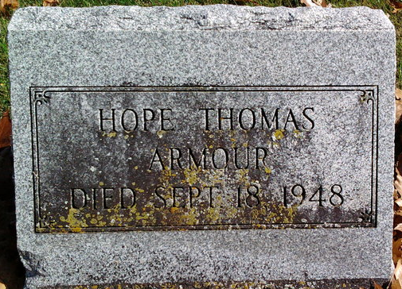
Photo by Thomas Liby
Hope Armour
in the Ohio, U.S., Death Records, 1908-1932, 1938-2018
Name Hope Armour
Death Date 18 Sep 1948
Death Place USA
**
U.S., Newspapers.com™ Obituary Index, 1800s-current
Name Hope Thomas Armour
Gender Female
Death Age 55
Birth Date abt 1893
Residence Place 405 Ox - Iora
Death Date Abt 1948
Burial Place Bluffton, Ind.
Obituary Date 20 Sep 1948
Obituary Place Dayton, Ohio, USA
Newspaper Title Dayton Daily News
**
Indiana, U.S., Marriages, 1810-2001
Name Hope Thomas
Gender Female
Race White
Age 40
Event Type Marriage Registration (Marriage)
Birth Date 4 Feb 1908
Birth Place Bluffton, Indiana
Marriage Date 22 Apr 1948
Marriage Place Indiana, United States
Residence Place Columbus, Ohio
Father: Charlie Wallace Thomas
Mother: Cora Grove
Spouse: Robert E Armour

