Frederick Ardner
March 6, 1874 – April 13, 1959

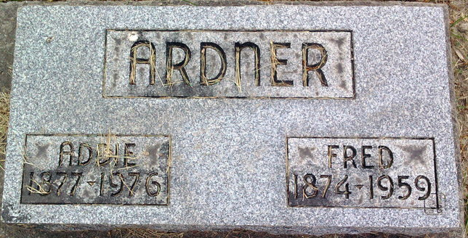
Photo by Thomas Liby
Frederick Ardner from Nancy (Heck) Ford Family Tree
Spouse Addie Bliss Webber
Father Phillp Ardner
Mother Magdalena Wahrer
Birth 6 Mar 1874 Monroeville, Allen, Indiana, USA
Death 13 Apr 1959 Bluffton, Wells, Indiana, USA
Residence Garfield, Harper, Oklahoma, USA

