Addie B. (Webber) Ardner
March 31, 1877 – June 8, 1976

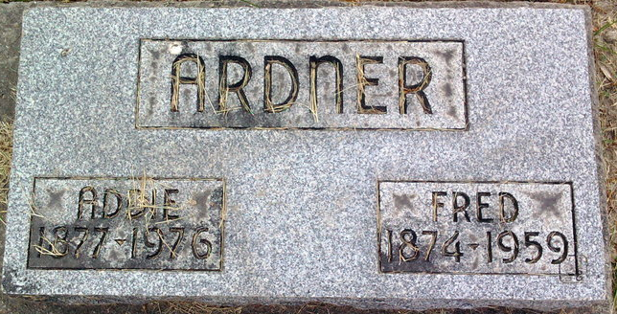
Photo by Thomas Liby
Addie B. Ardner
in the Indiana, U.S., Death Certificates, 1899-2017
Name Addie B. Ardner
[Addie B. Webber]
Gender Female
Race White
Age 99
Marital Status Widowed
Birth Date 31 Mar 1877
Birth Place Indiana
Death Date 8 Jun 1976
Death Place Bluffton, Wells, Indiana, USA
Death Registration Date 1976
Father: Zacharia T. Webber
Mother: Emma
Informant: Justus Webber; nephew; Bluffton, Indiana
Burial: June 10, 1976; Fairview Cemetery; Bluffton, Indiana

