Silver Archer
March 21, 1917 – April 29, 1917

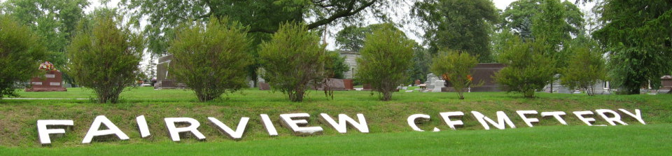
Photo by Tombstoner & Family
ARCHER BABE DEAD AT BLUFFTON
BLUFFTON, Ind., April 30 – Silver Archer, Jr., aged five weeks, died yesterday evening at the home of his parents on West Cherry Street. The parents survive, with two daughters. The funeral was held this morning. The father is a piano worker and the family here from Chicago only last week.
Journal Gazette; Allen County, Indiana
May 1, 1917

**
Birth • Illinois, Cook County, Birth Certificates, 1871-1949
Name Sylvester Archer
Sex Male
Birth Date 21 Mar 1917
Father's Name Sylvester Archer
Father's Sex Male
Father's Age 31
Father's Birth Year (Estimated) 1886
Mother's Name Bertha Juppenlatz
Mother's Sex Female
Mother's Age 28
Mother's Birth Year (Estimated) 1889
Event Type Birth Registration
Event Place Cook, Illinois, United States
Event Place (Original) , Cook, Illinois
Certificate Number 12024
Birthplace Chicago, Cook, Illinois, United States

**
Indiana, U.S., Death Certificates, 1899-2017
Name Silver Archer
Gender ?
Marital Status Single
Birth Date 21 ??1917
Birth Place ?? Illinois
Death Date 29 Apr 1917
Death Place Wells, Indiana, USA
Death Registration Date 1917
Father: Can't read
Mother: Can't read
Informant: Can't read
Burial: April 30, 1917; Fairview Cemetery
**
Wells County, Indiana Index to Death Records:
Silver Archer; male; age 1 month; d. April 29, 1917, Bluffton, Indiana

