Kathryn L. (Harris) Archbold
August 29, 1921 – May 23, 2006

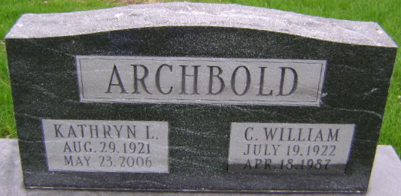
Photo by Bruce Sonner
Kathryn L Archbold
in the Indiana, U.S., Death Certificates, 1899-2017
Name Kathryn L Archbold
[Kathryn L Harris]
Gender Female
Race White
Age 84
Marital Status Widowed
Birth Date 29 Aug 1921
Birth Place Homily, Oklahoma
Death Date 23 May 2006
Death Place Decatur, Adams, Indiana, USA
Death Registration Date 2005
Father: Fred Harris
Mother: Velma Stoutenberry
Spouse: Charles W. Archbold; deceased
Informant: Carol Layman; Warren, Indiana
Burial: May 27, 2006; Fairview Cemetery; Bluffton, Indiana

