Charles William Archbold
July 19, 1922 – April 18, 1987

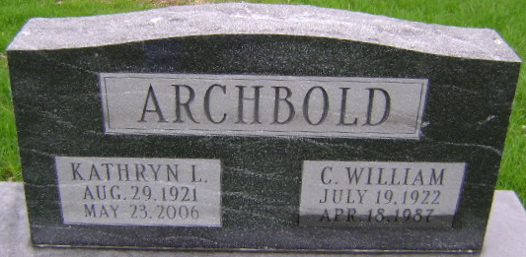
Photo by Bruce Sonner
Charles W Archbold
in the Indiana, U.S., Death Certificates, 1899-2017
Name Charles W Archbold
Gender Male
Race White
Age 64
Marital Status Married
Birth Date 19 Jul 1922
Birth Place Indiana
Death Date 18 Apr 1987
Death Place Fort Wayne, Allen, Indiana, USA
Death Registration Date 1987
Father: Lawrence E Archbold
Mother: Alice C Elliott
Spouse: Kathryn L Harris
Informant: VA Medical Center; Fort Wayne, Indiana
Burial: April 21, 1987; Fairview Cemetery; Bluffton, Indiana

