Melissa (Garrett) Applegate
February 1, 1973 – February 20, 2019

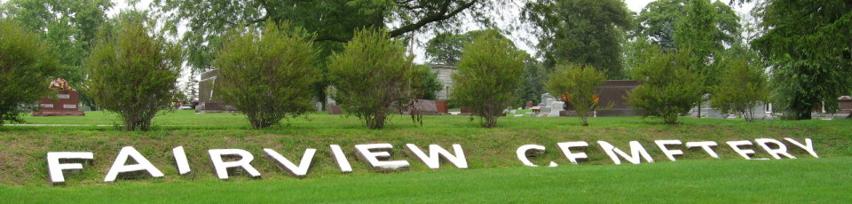
Photo by Thomas Liby
Melissa A. Applegate, 46, of Huntington passed away on Wednesday morning, February 20, 2019, at Hickory Creek at Huntington.
She was born on February 1, 1973, in Bluffton, Indiana to Roger D. & Juanita (Saunders) Garrett. Melissa attended Bluffton High School and was the owner/operator of the S & M Tattoo Shop in Bluffton for many years. She was a very kind hearted and giving person and would help anyone in need.
Survivors include her father Roger of Bluffton and four children; Jessyca (C. J.) Angel of Pikeville, TN, Samantha Applegate of Bluffton, Stephen Applegate of Huntington and Spring Applegate of Pikeville, TN, along with 3 grandchildren and a sister, Sandy (Mark) Habegger of Berne.
A service to celebrate Melissa’s life will be held at 7 P.M. on Saturday (February 23,2019) at the Thoma/Rich, Lemler Funeral Home in Bluffton with Pastor Neil Ainslie officiating. Friends are invited to visit with the family from 4 to 7 P.M. on Saturday, prior to the service. Burial will take place at Fairview Cemetery at a later date.
Memorials may be made to the family or to Family Life Care in Berne.

Thoma/Rich Funeral Home, Wells County, Indiana
February 21, 2019

