Eva May (Davis) Appelquist
February 8, 1896 – May 26, 1956

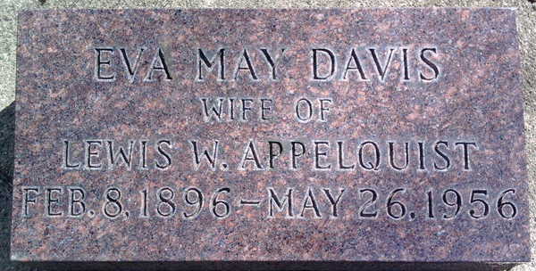
Photo by Thomas Liby
Eva May Davis from tree Gayle Elizabeth Popejoy Family History 10-01-2008
Birth 8 Feb 1896 Indiana, USA
Marriage 1929
Residence 1931 Urbana, Champaign, Illinois, USA
Death 26 May 1956 Bluffton, Wells, Indiana, USA
Father James Oscar Davis (1854-1915)
Mother Margaret Jennifer "Jennie" Lanning (1859-1918)
Spouse Lewis Wilhelm Applequist (1895-1981)

