Mary J. (Harrison) Anthony
1938 -

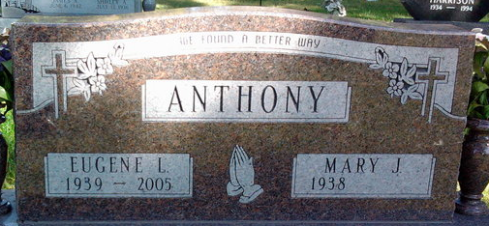
Photo by Thomas Liby

