Eugene L. Anthony
March 11, 1939 – February 19, 2005

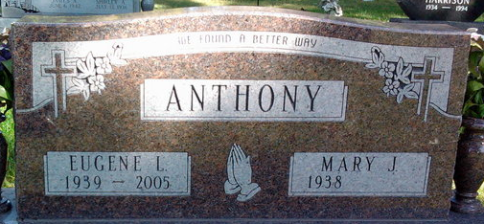
Photo by Thomas Liby
A truck driver for 35 years with three million miles of accident-free driving, Eugene L. Anthony, 65, of 827 South Oak St., Bluffton, died at 1:05 p.m. Saturday, Feb.19, 2005, at Bluffton Regional Medical Center.
In his trucking career, he drove 18 years for Dana Corp., 17 years for Schneider Corp. and part-time for First Fleet. He was a member of the Teamsters Union.
He was born March 11, 1939, at Plymouth, Ind., to Harold and Dorothy Higgins Anthony. His marriage to Mary J. Harrison was on Aug. 12, 1995, in Bluffton. She survives.
Also surviving are a son, Douglas E. Anthony of Bourbon, Ind.; a daughter, Mrs. James (Debra) Howie of Winona Lake, Ind; two stepsons, Rick and Randy Wolfe, both of Bluffton; five grandchildren, one great-grandchild and 4 step-grandchildren.
Visitation will be Tuesday from 1 to 8 p.m. at Goodwin Memorial Chapel where services will be at 1:30 p.m. Wednesday with Rev. Edward Johnson officiating. Burial will be in Fairview Cemetery.
Memorials to the family.

Bluffton News-Banner, Wells County, Indiana
February 21, 2005

