Lawrence Jonathan Anspach
May 14, 1906 – June 25, 1972

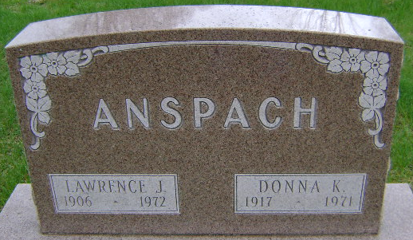
Photo by Bruce Sonner
Lawrence J. Anspach, 66, of 315 Hillcrest Road, Toll Gate Addition, died Sunday at Wells Community Hospital. A native of Paulding County, Ohio, he had resided in Wells County since 1951. He was born May 14, 1906, a son of Jonathan and Elthian Anspach. He was married to Donna Koenig, who died in January, 1971.
He attended the United Church of Christ.
Surviving are two sons, Elbert W. of Fort Wayne and Andrew with whom he made his home; one brother and two sisters, Harry R. Anspach, Miss Grace Anspach and Mrs. Elthian Wise, all of Fort Wayne, and six grandchildren.
Services will be Tuesday at the Thoma Funeral Home, Rev. Calvin Ley officiating; burial in Fairview Cemetery.

Wells County, Indiana Obituaries
September 24, 1972

