Donna K. (Koenig) Anspach
January 21, 1917 – January 22, 1971

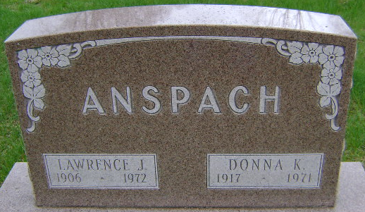
Photo by Bruce Sonner
Mrs. Donna K. Anspach, 54, died today at her home at 315 Hillcrest Road. Born January 21, 1917 in Bluffton, she was a daughter of Henry and Ethel Stogdill Koenig. She married Lawrence J. Anspach in October, 1949 at Bluffton.
She was a lifelong resident of Wells County and was a registered nurse at Wells Community Hospital.
Survivors include her husband, Lawrence; a son, Andrew K.
Funeral services are incomplete at the Thoma Funeral Home.

Wells County, Indiana Obituaries
January 22, 1971

