Andrew K. Anspach
July 29, 1950 – April 10, 2014

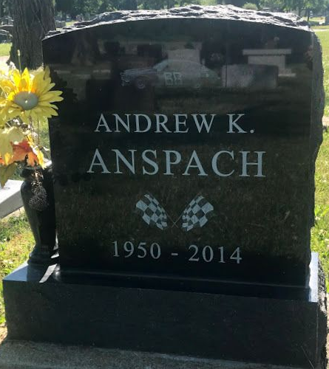
Photo by SMMR
Andrew K. Anspach, 63, died peacefully on Thursday, April 10, 2014. Born July 29, 1950, he was a son of the late Lawrence and Donna (Koenig) Anspach. He was a 1968 graduate of P.A. Allen High School, Bluffton, Ind. and also attended Tri-State University, Angola. He began his mechanical engineer career working for Industra Products, continued his career at Alliance Winding Equipment, and later he completed his career working at and retiring from American Machine & Tool. He was an avid fan of both the Chicago Bears and NASCAR while enjoying hobbies of golf and gunsmithing. He will be dearly missed by his many friends.
A service of "remembrance" is 2 p.m. Saturday, May 3, 2014, at Elzey-Patterson & Rodak Funeral Home, 6810 Old Trail Road, Fort Wayne, with calling one hour before. A "Celebration of Life" gathering is being planned at a future date. Burial in Fairview Cemetery, Bluffton. In lieu of flowers, donations may be made to Animal Care and Control.

Journal-Gazette, Allen County, Indiana
April 11, 2014

