Ricky T. Angel
January 21, 1963 – August 28, 1990

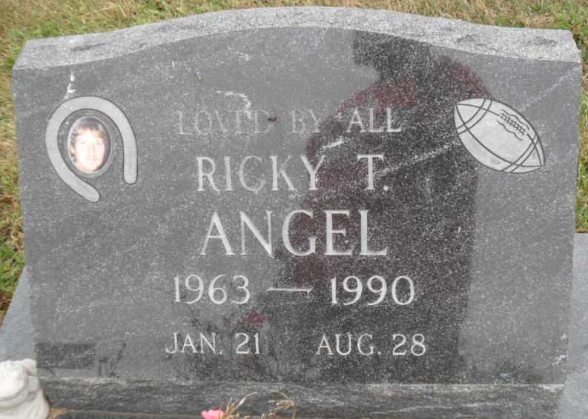
Photo by PLGS
Ricky T Angel
in the Indiana, U.S., Death Certificates, 1899-2017
Name: Ricky T Angel
Gender: Male
Race: White
Age: 27
Marital status: Married
Birth Date: 21 Jan 1963
Birth Place: Knox, Indiana
Death Date: 28 Aug 1990; suicide
Death Place: Gary, Lake, Indiana, USA
Death Registration Date: 1990
Father: Edgar Angel
Mother: Molly M Puckett
Spouse: Sherry Garet
Informant: Molly M. Rudd; mother; Bluffton, Indiana
Burial: August 31, 1990; Fairview Cemetery; Bluffton, Indiana

