Randy Angel
November 18, 1961 – December 22, 2020

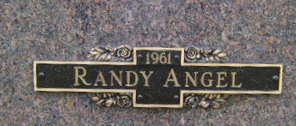
Photo by Bruce Sonner
Randy Angel, 59 of Bluffton, passed away on Tuesday, December 22, 2020, at his residence in Bluffton. Randy was born on November 18, 1961 in Knox, Indiana to Edgar (Babe) Angel and Mollie M. (Puckett) Rudd.
He graduated from Boyd County High School and attended Ivey Tech. to study in the HVAC Program. He worked at Bluffton Rubber Company and at Peyton’s Northern, both in Bluffton. Randy was an avid Chicago Cubs fan and enjoyed spending time outdoors, especially fishing.
Randy is survived by his siblings; Irene (Kenneth) Blankenship of Gary, Carolyn Sue (Don) Rowe of Catlettsburg, KY, Edgar Raymond (Lori) Angel of Merrillville, Ethel Marie Angel of Ashland, KY, Jack (Desire' Green) Morlan of Craigville, Gladys Susie Coffield of Tocsin, William C. Rudd, Jr. of Paintsville, KY, Milinda Sue (Ronnie) Cross of Fort Wayne, Marsha Ann (Frank) James of Bluffton, along with many nieces and nephews
Randy is preceded in death by his parents, a longtime companion, Anne Davis and a brother Ricky Troy Angel.
Entombment will follow the service at Northridge Community Mausoleum, located at Fairview Cemetery.

Thoma/Rich Funeral Home, Wells County, Indiana
December 23, 2020

