Margaret Angel
April 23, 1766 – February 13, 1853

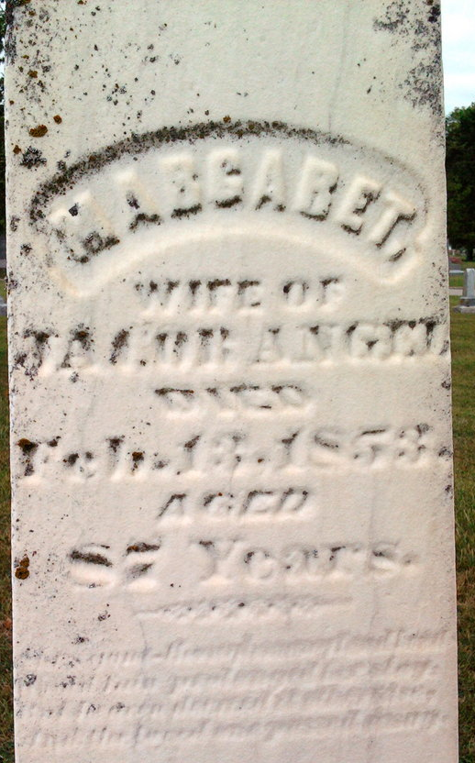
Photo by Thomas Liby
Margaret Angel from Blanton Family Tree
Spouse Jacob Angel
Children David
Birth 23 Apr 1766 Pennsylvania, USA
Death 13 Feb 1853 Wells, Indiana, USA
Residence 1850 Bluffton, Wells, Indiana, USA

