Jane Edna Angel
December 25, 1827 – September 11, 1845

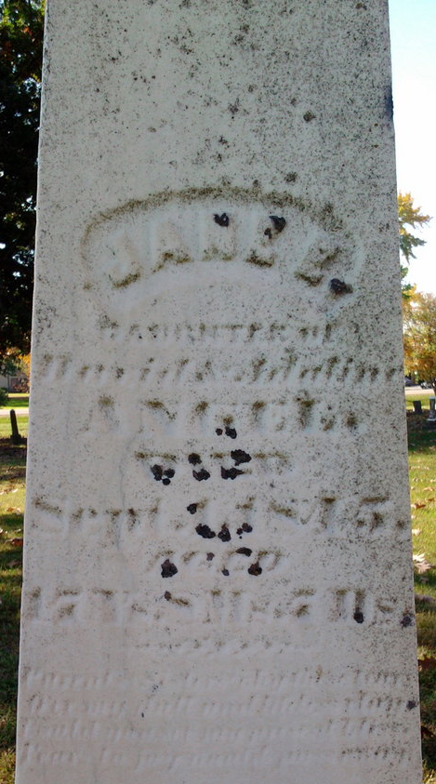
Photo by Thomas Liby
Jane Edna Angel from Blanton Family Tree
Father David Angel
Mother Adaline Porter
Birth 1829 Montgomery, Ohio, USA
Death 11 Sep 1845

