David Angel
June 23, 1799 – February 5, 1864

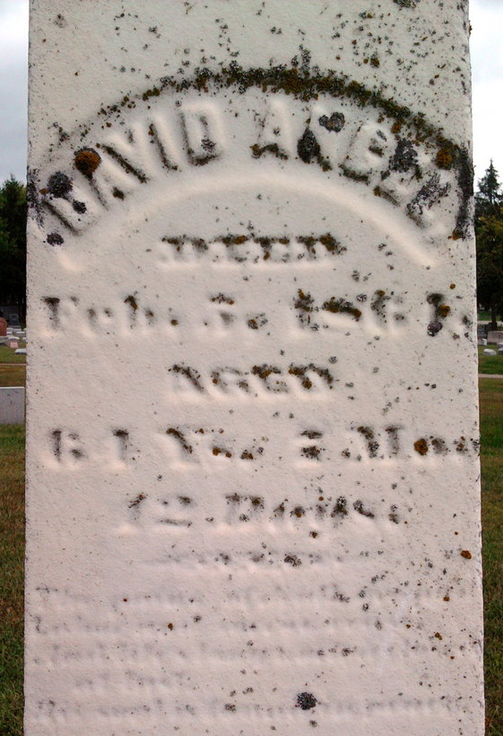
Photo by Thomas Liby
David ANGEL from 2014 Rogers-Irons Master File(1)
Spouse Adeline PORTOR
Father Jacob Angel
Mother Margaret Angel nee ?
Children Adeline
Birth 23 Jun 1799 Maryland, USA
Death 5 Feb 1864 Bluffton, Wells, Indiana, USA
Residence 1860 Bluffton, Wells, Indiana, USA

